Super Duck Invaders User Manual

**Controls:**

**WASD** - Running or swimming (i.e. W=up, A=left, S=down, D=right)

**Space bar**  - Dash/Fly (flight lasts for one second and takes 5 to recharge.  
 Recharge time is shown in the yellow bar in the bottom left.)

**Left Mouse Click**  - Melee Attack

**Right Mouse Click**  - Shoot in the direction of the mouse pointer

**V** - Take a screenshot

**Pickups:**

* Pickups give you abilities to help you achieve a higher score in your game.
* They are collected by moving over them.
* Only one temporary pickup can be held at any time. A temporary pickup will be replaced if you walk over a another different pickup.
* The time that you have remaining to use your current temporary pickup is shown in the blue bar located at the bottom right corner of the screen.

**Types of Pickup:  
Weapons:**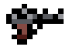

* **Guns** - Guns are permanent pickups, you are able to shoot bullets to kill enemies. Each kill of an enemy is worth 10 points.



* **Lightsaber** - Permanent pickups, you get the ability to deflect bullets, like a real jedi.



**Powerups:**

* **Speed** - This is a temporary pick up. The player’s movement speed is increased by x3.



* **Rate of fire** - This is a temporary pick up. The gun’s rate of fire is increased by x5.



* **Shield** - This is a temporary pick up. The player is invulnerable for 5 seconds.



* **Score Boost** - This is a temporary pick up. The player get x5 score multiplier.



**Heart** - This increases your health level by 1.

**Objective:**

The objective of each level is displayed in the top left hand corner. There are 3 types of objectives:

1. SURVIVE
   * Stay alive for a certain amount of time
2. KILL
   * Kill a certain number of enemies
3. REACH
   * Locate and capture the flag located on the map.

The aim is to achieve these objectives whilst scoring as many points as possible.

**Demented Ducks:**

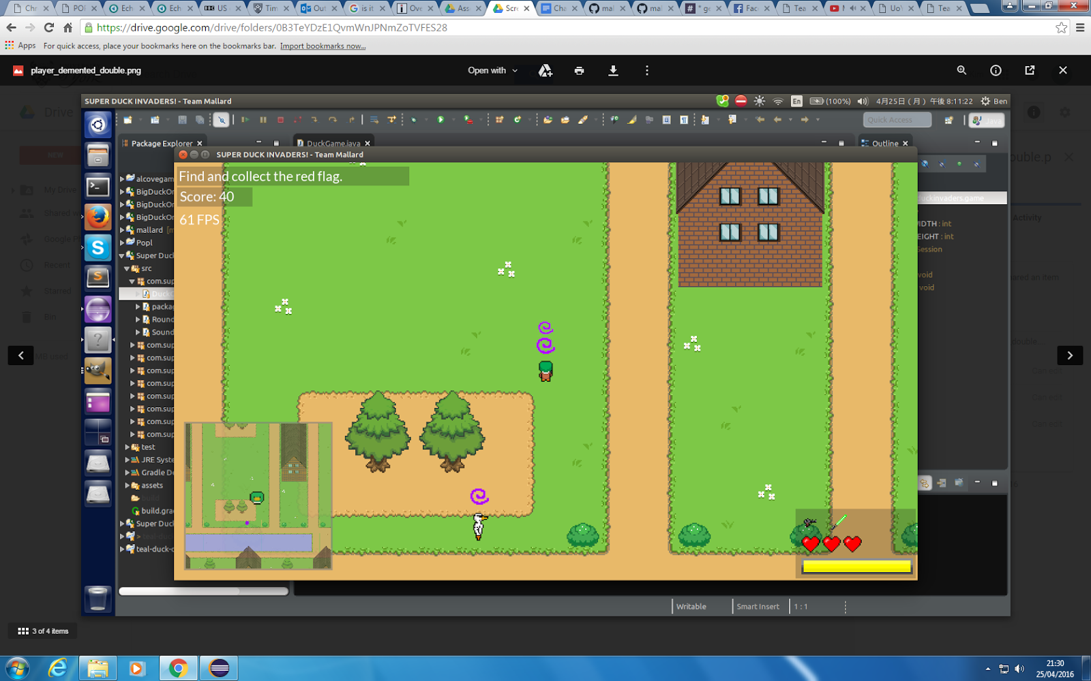

At certain random points of the game the enemies will become demented. If you touch the duck you will also become demented. This is shown by the purple spiral. When a second smaller spiral appears over the player the duck will contradict the user input. The ducks are cured after a certain amount of time.